AI Creative Analysis Pipeline
Automated Video-to-Notion Documentation System
n8n • Google Drive • Gemini 2.0 Flash • ChatGPT • Notion

Field | Details
Trigger | New video uploaded to Google Drive folder
Platform | n8n
Integrations | Google Drive API, Gemini 2.0 Flash, ChatGPT, Notion API
AI Models | Gemini 2.0 Flash (analysis) + ChatGPT (adaptation)
Output | Structured Notion page with creative table and embedded video

1 Project Overview
This project is a fully automated creative analysis and content structuring pipeline designed to transform raw marketing videos into structured, reusable, and production-ready creative frameworks stored in Notion.

The system continuously monitors a Google Drive folder for newly uploaded videos. When a new video is detected, the workflow automatically:

- Downloads the video file
- Sends the video to Gemini 2.0 Flash for structured creative analysis
- Passes the structured output to ChatGPT for strict linguistic adaptation and formatting
- Converts the result into a Notion-compatible format
- Creates a dedicated Notion page with a dynamic title
- Inserts a structured creative table inside the page
- Embeds the original video directly inside the same page

This design ensures that every creative analysis exists as a self-contained Notion page, combining both the framework and the original source video in one location.

2 Problem Statement
Marketing and creative teams often analyze high-performing video creatives manually to extract hooks, emotional beats, product reveals, proof points, and calls-to-action. This process is time-consuming, inconsistent, and difficult to scale.

The goal of this project is to automate the creative analysis process end-to-end while ensuring:

- Structural consistency across all analyzed creatives
- Strict sentence-level language mapping
- Visual and audio documentation
- Direct storage in a production-ready system (Notion)

3 Core Technologies
Technology | Role
n8n | Workflow automation engine
Google Drive API | Video ingestion and trigger system
Gemini 2.0 Flash | Creative video analysis and structured table generation
ChatGPT | Linguistic adaptation and strict 1:1 script formatting
Notion API | Storage, visualization, and creative documentation
JavaScript (Code Node) | JSON transformation and API payload formatting

4 Workflow Diagram
The diagram below illustrates the full n8n automation pipeline from Google Drive trigger through to Notion output:

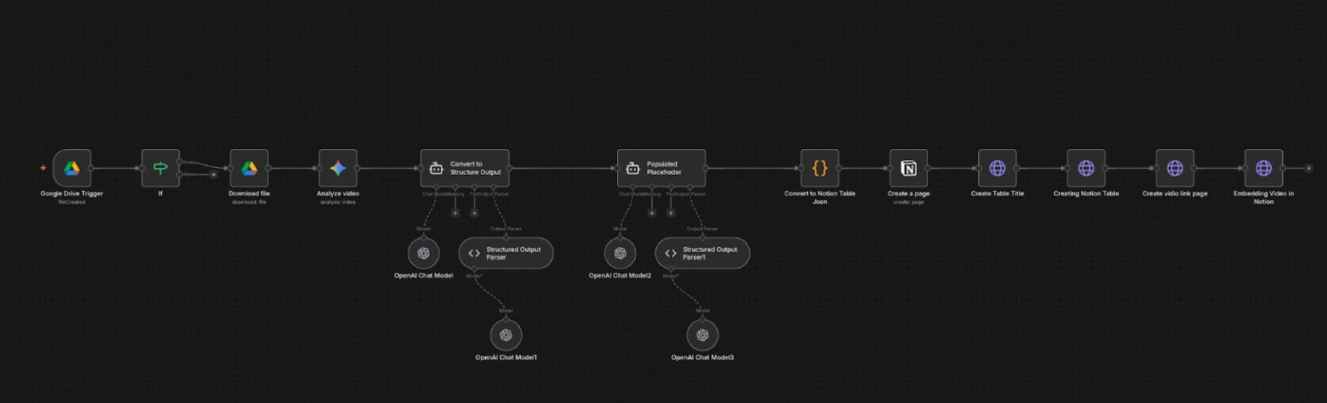

5 Automation Flow — Node by Node
# | Node | Action
1 | Google Drive Trigger | New video detected in monitored folder
2 | Download File Node | Raw video fetched from Google Drive
3 | Structured Agent — Gemini 2.0 Flash | Video analyzed, creative framework table generated
4 | Filling Placeholder Agent — ChatGPT | Output adapted with strict 1:1 sentence formatting
5 | Code Node | AI output converted to Notion API-compatible JSON
6 | Notion Page Creation | Blank parent page created in Notion workspace
7 | Create Page Title | Dynamic title applied using video filename/metadata
8 | Create Notion Table | Six-column creative table inserted into the page
9 | Embed Video Node | Original video embedded for creative reference

6 Node-Level Details
6.1 Google Drive Trigger
Monitors a specific Google Drive folder for new video uploads. Fires when a new file is added and captures metadata such as file name, file ID, MIME type, and public web link.
6.2 Download File Node
Downloads the raw video file for AI processing. Fetches binary video data from Google Drive and prepares the file for ingestion by the Gemini analysis agent.
6.3 Structured Agent — Gemini 2.0 Flash
Analyzes the full video and generates a structured creative framework table. The agent is designed to be product-agnostic using placeholder-based rewriting and line-by-line script breakdown.

Gemini generates a six-column output table:

Column | Description
Framework Section | Hook, Conflict, Solution, Proof, CTA
Reference Script | Original spoken script (unaltered)
Script Breakdown | Universal placeholder-based rewrite
Visual Description | On-screen visuals and editing cues
Shot Type | Camera framing and angle
Audio | Voice, music, and sound design

All product- or niche-specific language is replaced with universal placeholders such as [problem], [product], and [benefit] to ensure the framework can be reused across industries and campaigns.
6.4 Filling Placeholder Agent — ChatGPT
Transforms Gemini's structured output into a strictly formatted, production-ready table. Core rules enforced include exactly six columns, strict 1:1 sentence adaptation, no added or removed phrases, same emotional pacing, same reading duration, spoken Québec French style, and preserved visual and audio alignment.

Product context applied for this workflow: Linge à vaisselle Aloha — Buy 2, Get 2 Free. Promotional elements are injected only where structurally appropriate in the original script.
6.5 Code Node — JSON to Notion Formatter
Converts the AI-generated structured output into a Notion API-compatible payload. Responsibilities include parsing structured AI output, extracting table rows and columns, mapping values to Notion block schema, and preparing the video embed block.
6.6 Notion Page Creation Node
Creates a new parent page inside the target Notion workspace or database. Sends a request to the Notion API to create a blank page and returns a unique page identifier used as the container for all downstream operations.
6.7 Create Page Title Node
Applies a dynamic title to the newly created Notion page using the returned page ID. Title is based on contextual metadata such as video file name, campaign name, or timestamp — for example: Creative Analysis – ad_video.mp4
6.8 Create Notion Table Node
Inserts the structured creative framework table into the titled page. Maps all six AI-generated columns into Notion table rows, preserves row order and framework section grouping, and optionally attaches metadata fields such as date, product, campaign, and language.
6.9 Embed Original Video Node
Embeds the original Google Drive video directly inside the same Notion page for visual reference and creative validation. Uses the webViewLink from the Google Drive Trigger to create a Notion embed block positioned alongside the structured table.

7 Notion Output Structure
Each processed video generates a single structured Notion page containing all components in one location:

Icon | Element
📄 | Notion Page
📝 | Page Title (dynamic — video filename/timestamp)
📊 | Structured Creative Table (six columns)
🎥 | Embedded Original Video
🏷️ | Metadata: Date, Product, Campaign, Language

This structure supports filtering, creative comparison, framework reuse, and production handoff.

